

RETIREE NEWSLETTER
Produced for retired members of The General Retirement System for Employees of Jefferson County Winter 2024
Contacting GRS
We are available Monday through Friday, 8:00 a.m.—4:30 p.m. Our number is (205) 325-5354. You can also email us at questions@grsal.net or visit us on the web at www.grsal.net.

How to Read Your 1099-R
As a GRS retiree or beneficiary, you may receive a 1099-R form mailed no later than January 31st. The 1099-R issued by GRS is used to report distributions from GRS.
Box 1: This is the gross benefit you received from GRS.
Box 2a: This is the taxable portion of your GRS benefit as calculated by GRS. GRS uses the Simplified General Rule to calculate the taxable amount.
Box 4: This is the federal income tax withheld by GRS in 2023.

Box 5: This is the nontaxable portion of your GRS benefit as calculated by GRS. GRS uses the Simplified General Rule to calculate the taxable amount.

Box 7: This is the type of distribution you are receiving.
You may wish to consult a professional tax advisor or obtain additional information from the IRS by visiting a local IRS office, on the web at www.irs.gov, or by calling 1-800-829-1040.

1099-Rs will be mailed no later than January 31, 2024. If you need another copy of your 1099-R, you may get a copy in MemberDirect or request a reprint from our office by calling (205) 784-4530.
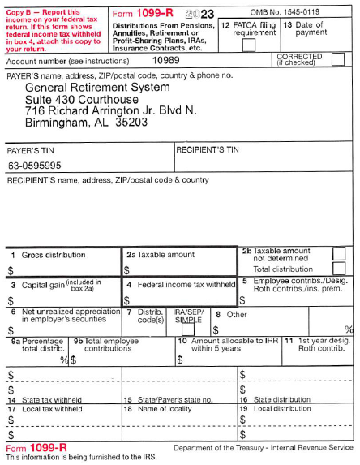
Information from Human Resources
With respect to your retirement benefits, you and/or your eligible dependent spouse will automatically be removed from the County’s BCBS health plan on the 1st day of the month in which you and/or your spouse turn 65 and become Medicare eligible. For example, if your birthday is February 28 your coverage will end on February 1. If your spouse is not 65 at the time you become Medicare eligible, they will be enrolled as the primary account holder along with any remaining eligible dependents. Dependent children will remain covered through the end of the month in which they turn 26 and will also be removed automatically.
If you and/or your dependent spouse become Medicare eligible prior to reaching age 65 or your dependent child becomes Medicare eligible prior to reaching age 26, it is your responsibility to report this information to Jefferson County Commission HR Benefits team by emailing Benefits@jccal.org at the earliest date of notification from the Social Security Administration. It is also your responsibility to inform Benefits in order to certify your disabled/incapacitated dependents who are age 26 or older.
Please note that if you are also enrolled in the dental and/or vision plan(s), coverage will not end automatically at the same time the BCBS Health plan ends. If you would like to terminate dental and/or vision coverages, please call the HR Benefits team at (205) 325-5249, Option 4 or email Benefits@jccal.org. It is important to note that if you terminate your dental and/or vision coverages, you cannot re-enroll at a later date.

We are trying to locate the following members. If you know one of the individuals below, please ask them to contact our office.
Larry Earl Guthrie Stephen Fox McGhee
Veronica L. Merritt Scotty Ray Sanford
Myranda Richardson Jemica Lashun Rowe
Ashley Denecia Thomas Marlee Elena Bell
Kevin Blaylock Milton Levon Burton
Adam Thomas Ennis Andrina Denea Lando
Markell Jones Christopher Finley
Joshua Caleb Adams Gabriel Posey
William David McKoy Xavier Purdue
Fredrick Carson Jernesia Melton
Ivory Price Miranda Pilato
Lenora Davis Mary Ward
Cynthia Chandler Haresh Modi
Rodney Franklin, Jr.

We are trying to locate the following members. If you know one of the individuals below, please ask them to contact our office.
Ginger Beasley Brett Cooksey
Wayne Heard Darryl Curry
Dvaria Hurst Bee Landrum
Zachary Martin Keanthony Newson
Michael Allen Patrick Bishop
Enoch Brown Adrian Carpenter
Umamaheswara Garlapati Amy Lloyd
Anglelyn Washington Virginia Walker
Jonathan Turner Calvin Tucker
Seprina Thomas Jonathan Truitt
Ginger Simms Kedrick Miller
Joshua Spinks Pattrice Frazier Coleman
Chardone Croom Nicholas Reynolds
Shedrick Adrian South Dennis Chance Tidwell
Arthur Wyn Lisa Bartels

Stay in Touch with GRS
When you move, don’t forget to let us know your new address. Even if you get your benefit check deposited directly into your bank account, GRS may need to contact you with important information. Your benefits may be suspended if your mail is returned to GRS, so make sure you keep your address up to date.

2024 Direct Deposit Payment Schedule
Monday, January 22, 2024
Thursday, February 22, 2024
Friday, March 22, 2024
Monday, April 22, 2024
Wednesday, May 22, 2024
Monday, June 24, 2024
Monday, July 22, 2024
Thursday, August 22, 2024
Monday, September 23, 2024
Tuesday, October 22, 2024
Friday, November 22, 2024
Monday, December 23, 2024
Direct Deposit Changes
If you make any changes to the account for your monthly Direct Deposit you need to notify us by the 5th of the month for the change to be effective for the month. You can get a Direct Deposit form on our website, www.grsal.net or you can make the change in MemberDirect.
Contacting GRS
We are available Monday through Friday, 8:00 a.m.—4:30 p.m. Our number is (205) 784-4530. You can also email us at questions@grsal.net or visit us on the web at www.grsal.net.
Pension Board
Robert Field, Chairman
Robert Nolen, Member 2
Connie Harris, Member 3
Billy Morace, Member 4
Travis Hulsey, Member 5

